CITI Training
- Go to citiprogram.org.
- Click on the REGISTER button. You must register before you can log into the system.
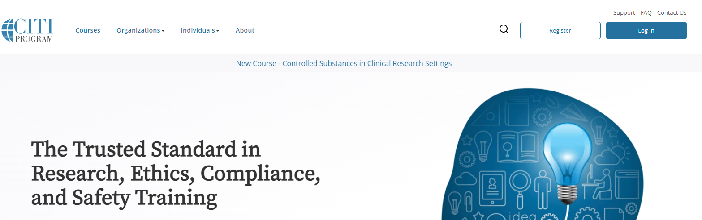

- Enter KANSAS HEALTH SCIENCE CENTER in the box (this choice should appear).
N.B.: Kansas College of Osteopathic Medicine doesn’t work.
- Click the I AGREE and I AFFIRM buttons. Do not use the Independent Learner option.
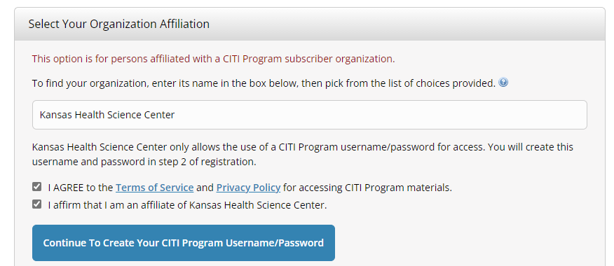

- Follow the instructions that appear (name, email, address, etc.). CITI is part of our SSO.
- Select the BIOMEDICAL COMPREHENSIVE option, plus any other option you wish. This isn’t a life or death choice: you can add/delete other courses once you’ve completed registering.
- To log in go to the link above and select LOG IN. You can use your SSO credentials.
- Questions? Go to Guide to Getting Started or Getting Started Video.
If you have any questions, please let me know. I’m happy to come to your office to help.

Cheers,

